**Create a Spring Web Project using Maven**

package com.cognizant.springlearn;  
  
import java.text.ParseException;  
import java.text.SimpleDateFormat;  
  
import org.springframework.boot.SpringApplication;  
import org.springframework.boot.autoconfigure.SpringBootApplication;  
import org.springframework.context.ApplicationContext;  
import org.springframework.context.support.ClassPathXmlApplicationContext;  
  
@SpringBootApplication  
public class SpringLearnApplication {  
   
 public static void displayDate() {  
 ApplicationContext context = new ClassPathXmlApplicationContext("date-format.xml");  
 SimpleDateFormat format = context.getBean("dateFormat",SimpleDateFormat.class);  
 try {  
 System.out.println(format.parse("10/07/2025"));  
 } catch (ParseException e) {  
 e.printStackTrace();  
 }  
   
 }  
  
 public static void main(String[] args) {  
 displayDate();  
 SpringApplication.run(SpringLearnApplication.class, args);  
 }  
  
}

package com.cognizant.springlearn;  
  
import org.junit.jupiter.api.Test;  
import org.springframework.boot.test.context.SpringBootTest;  
  
@SpringBootTest  
class SpringLearnApplicationTests {  
  
 @Test  
 void contextLoads() {  
 }  
  
}

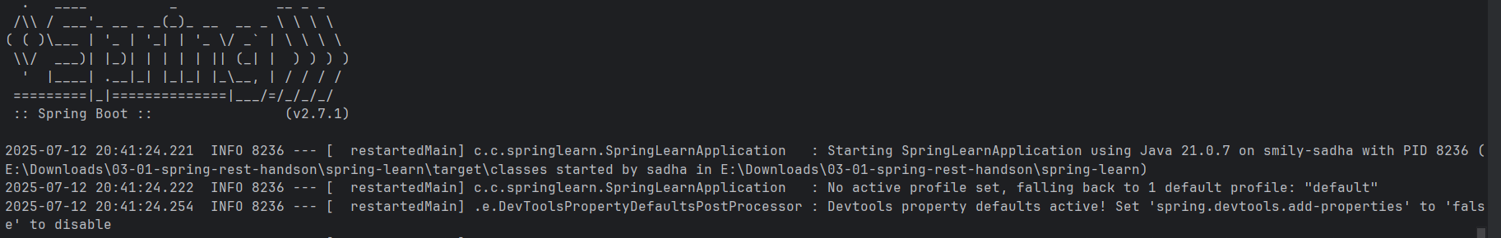

**Spring Core – Load Country from Spring Configuration XML**   
  
package com.cognizant.springlearn;  
  
import org.slf4j.Logger;  
import org.slf4j.LoggerFactory;  
import org.springframework.boot.SpringApplication;  
import org.springframework.boot.autoconfigure.SpringBootApplication;  
import org.springframework.context.ApplicationContext;  
import org.springframework.context.support.ClassPathXmlApplicationContext;  
  
@SpringBootApplication  
public class SpringLearnApplication {  
  
 private static final Logger *LOGGER* = LoggerFactory.*getLogger*(SpringLearnApplication.class);  
  
 public static void main(String[] args) {  
 *LOGGER*.info("START");  
 *displayCountry*();  
 SpringApplication.*run*(SpringLearnApplication.class, args);  
 *LOGGER*.info("END");  
 }  
  
 public static void displayCountry() {  
 ApplicationContext context = new ClassPathXmlApplicationContext("country.xml");  
 Country country = context.getBean("country", Country.class);  
 *LOGGER*.debug("Country : {}", country.toString());  
 }  
}

package com.cognizant.springlearn;  
  
import org.slf4j.Logger;  
import org.slf4j.LoggerFactory;  
  
public class Country {  
  
 private static final Logger *LOGGER* = LoggerFactory.*getLogger*(Country.class);  
  
 private String code;  
 private String name;  
  
 public Country() {  
 *LOGGER*.debug("Inside Country Constructor.");  
 }  
  
 public String getCode() {  
 *LOGGER*.debug("Inside getCode");  
 return code;  
 }  
  
 public void setCode(String code) {  
 *LOGGER*.debug("Inside setCode");  
 this.code = code;  
 }  
  
 public String getName() {  
 *LOGGER*.debug("Inside getName");  
 return name;  
 }  
  
 public void setName(String name) {  
 *LOGGER*.debug("Inside setName");  
 this.name = name;  
 }  
  
 @Override  
 public String toString() {  
 return "Country [code=" + code + ", name=" + name + "]";  
 }  
}

